**SQL Server Test**

1. Get First_Name from employee table using alias name “Employee Name”

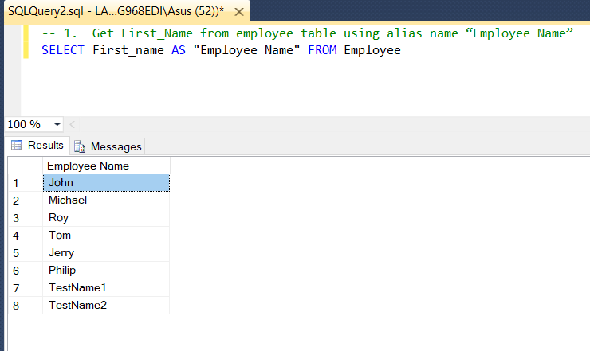

1. Get position of 'o' in name 'John' from employee table

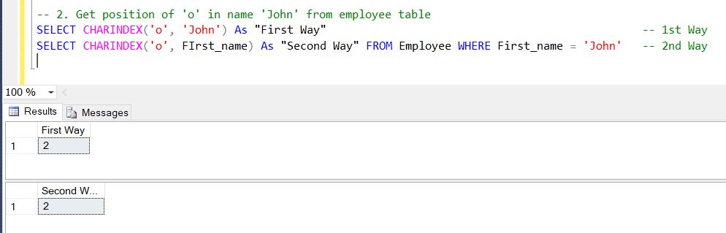

1. Get FIRST_NAME ,Joining year,Joining Month and Joining Date from employee table

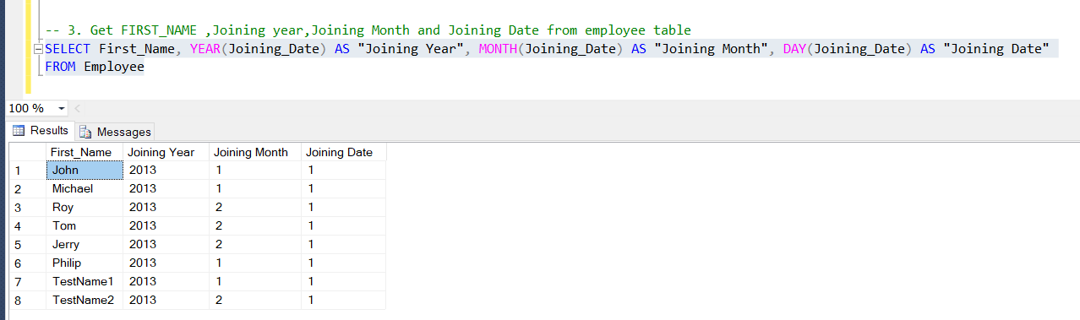

1. Get all employee details from the employee table order by First_Name Ascending and Salary descending

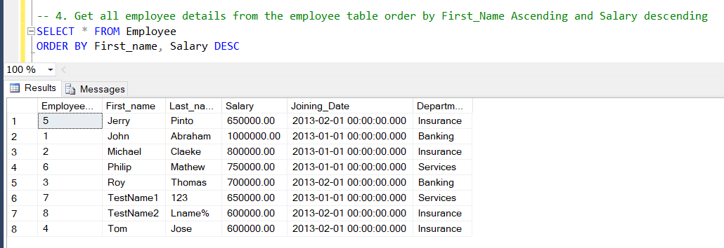

1. Get employee details from employee table whose employee name are not “John” and “Roy”

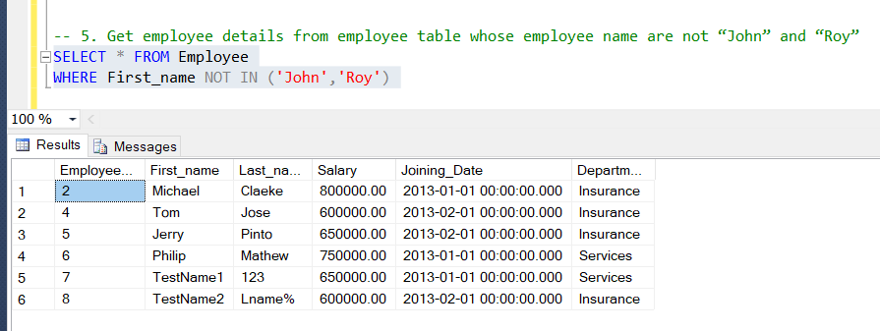

1. Get employee details from employee table whose first name ends with 'n'

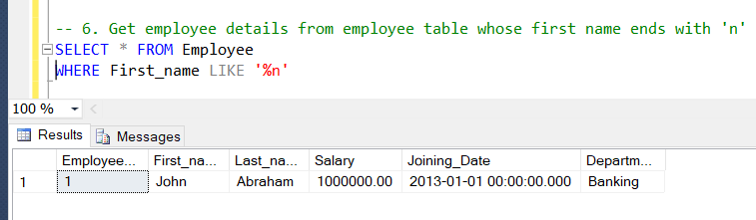

1. Get employee details from employee table whose first name ends with 'n' and name contains 4 letters

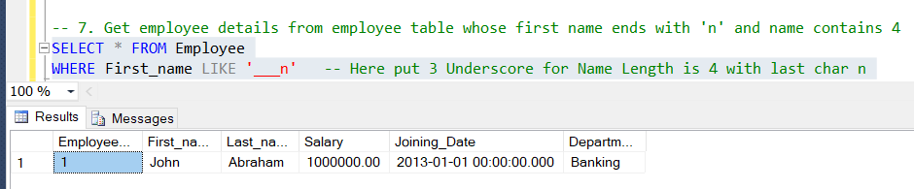

1. Get employee details from employee table whose Salary less than 800000

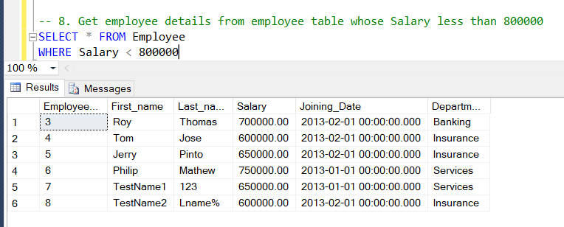

1. Get employee details from employee table who joined before January 1st 2013

* 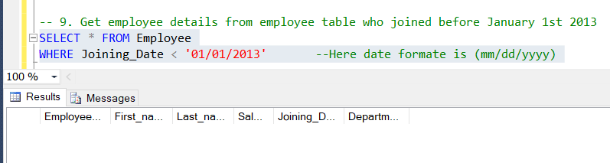Here Don’t show any data because all Employee are joining at or after 01-Jan-2013

1. Get difference between JOINING_DATE and INCENTIVE_DATE from employee and incentives table

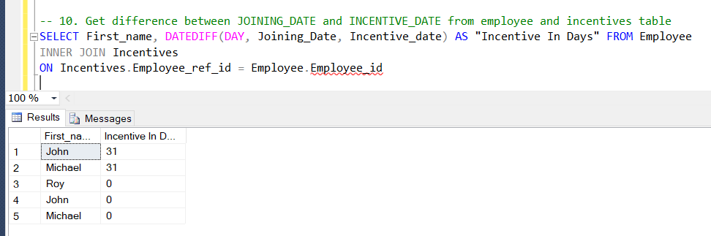

* Here show error in Employee_id because first time by mistake Employee_is it’s rename then it’s show red line but query is also runble

1. Print database date.

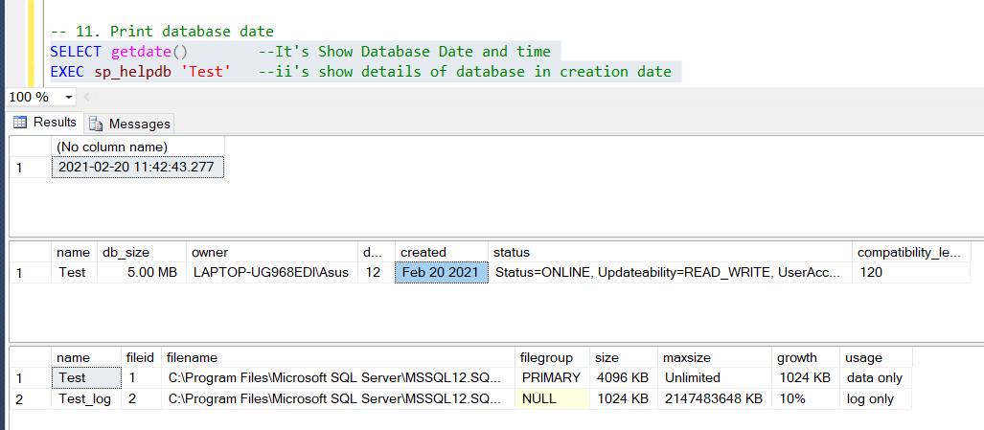

1. Get department, total salary with respect to a department from employee table.

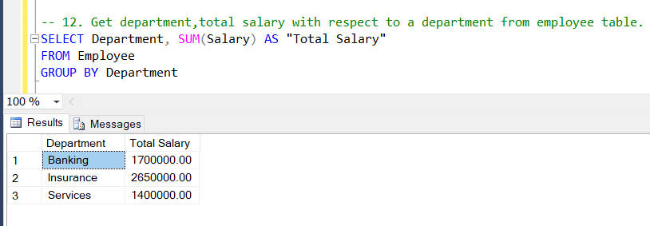

1. 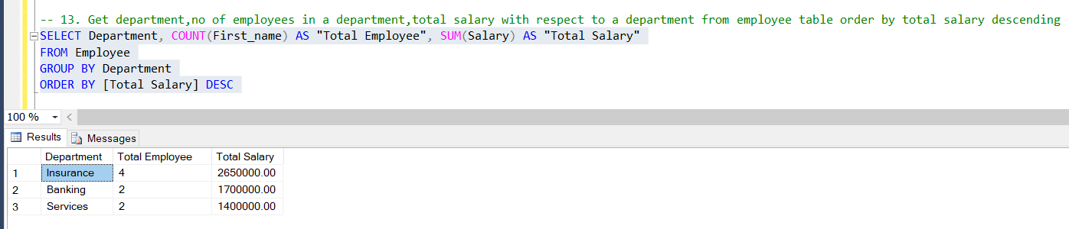 Get department, no of employees in a department, total salary with respect to a department from employee table order by total salary descending .
2. 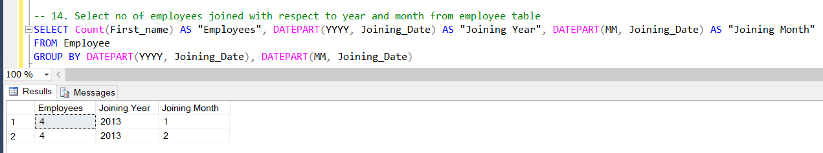 Select no of employees joined with respect to year and month from employee table
3. Update incentive table with employee's Incentive_amount as '12000' where employee name is 'John'

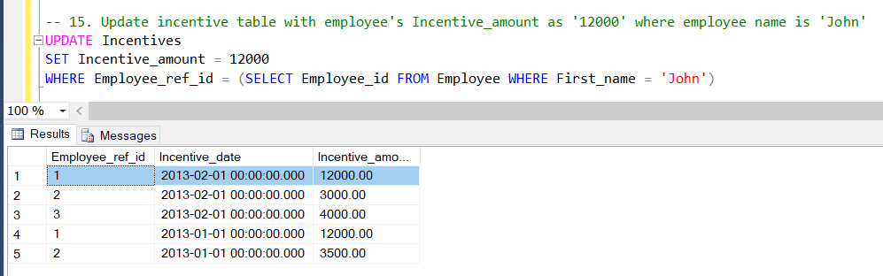

* Here Record Updated

1. Select TOP 2 salary from employee table

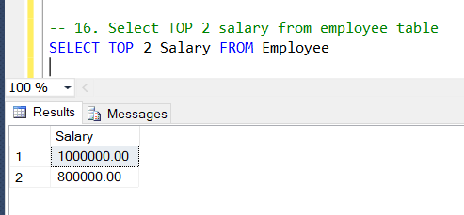

1. Select 2nd Highest salary from employee table

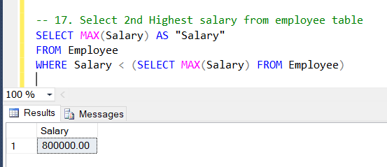

1. What is the difference between UNION and UNION ALL ?

Answer : Union is return distinct value but Union All return all values

including Null.

1. Write a syntax for CREATE Employee Table

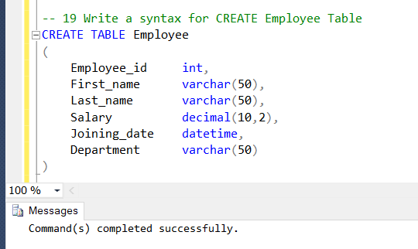

1. Write a syntax for truncate all data from Emplyee Table.

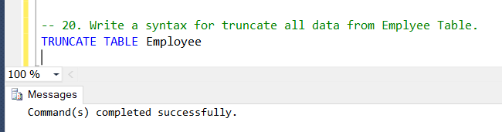

1. Write a syntax for CREATE Procedure to display the Employee details by passing the “Employee Id” in the procedure.

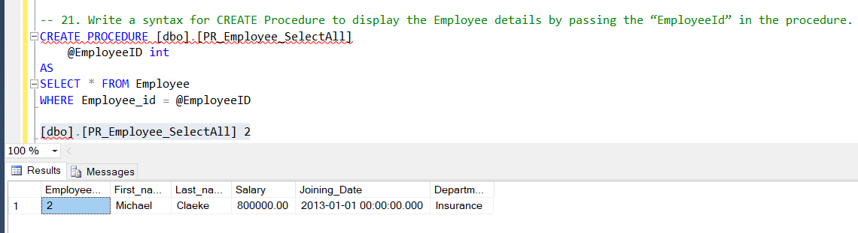

1. Write a syntax for CREATE SQL function, which accept three number as argument and return the highest number

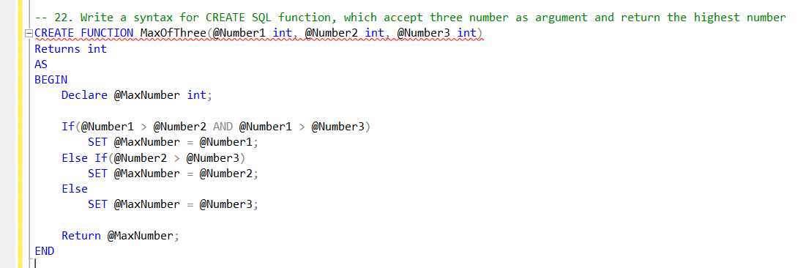

1. Write a syntax for Update the Employee's salary whose department is “Insurance”.

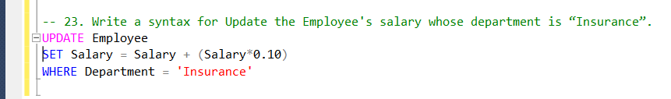

1. State the difference between varchar and nvarchar

Answer : varchar is stored as 1 byte per character and nvarchar stores data at 2 bytes per character. Due to this reason, nvarchar can hold upto double the space as SQL varchar.

1. Write a query that insert the data into Employee table, data as mentioned. {First name : 'Critiano' , Last name : 'Ronaldo' , Salary : '30000' , Joining Date : '01-FEB-13 12.00.00 AM' , Department : 'Banking' }

